Statistical scaling properties of planetary topographic fields

F. Landais¹ F. Schmidt¹, S. Lovejoy²
(1) Univ Paris-Sud/CNRS, GEOPS, UMR8148, Orsay, F-91405, France, (francois.landais@u-psud.fr)(2) Physics, McGill University, Montreal, Quebec
Key words : Topography, statistical properties, scaling laws.

The massive acquisition of altimetric data in the solar system has motivated numerous analysis of the topography of planets, in particular the surface roughness. A possible approach is to assume that topography can be mathematically described as a statistical field with quantitative parameters able to characterize the geological units. Many statistical indicators have been proposed and widely explored in order to study the surface of plantets: RMS height, RMS slope, median slope [1], autocorrelation length [2]. Useful informations have been obtained by the use of those indicators but they have the disadvantage of been defined at a given scale. By construction, they do not directly take into account the well-established scale symmetry that generally occurs in the case of natural surfaces. Indeed, topography can not be interpreted as a stationary field, meaning that statistical parameters like the mean or the standard deviation exhibit a dependence toward scales. Hence the nature of this dependence needs to be accurately explained, otherwise the description of the surface remain incomplete. This subject has been widely studied in the past, parallel to the development of the notion of fractals ([3]). It is now well established that topography is often efficiently modelled by fractal simulations. More interestingly, the fractal theory provides a mathematical formalism to describe the scale dependence of statistical parameters toward scales. It turns out that simple power-law relations efficiently approach the variability of planetary surfaces. The associated power-law exponent provides a quantitative parameter that is a good scale-independent candidate to characterize the geometric properties of a natural surface. A common example is given by the power spectrum of topographic field providing roughness information in the frequency space.

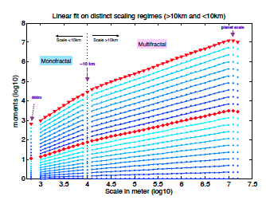
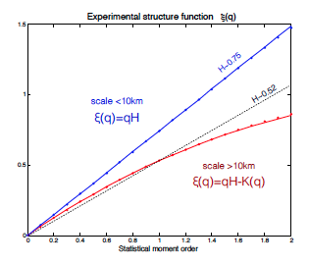
However, The observed intermittency (spatial dependance of the scaling laws) [4] apparently rejects the idea of a global description of any topographic field at the planetary scale. Still, modern developments in the fractal theory might be able to give full account to the observed variability and intermittency. As proposed by [5], it is possible to extent the fractal interpretation of topography to a multifractal statistical object requiring an infinite number of fractal dimensions (one for each statistical moment order). In the present study, we analyse the global scaling laws of topography for different body in the solar system in order to test the multifractal formalism. We then compare the fractal and multifractal parameters form a body to the other. Figure 1 an d 2 show the case of Mars. Multiscaling seems to occur on a large but restricted range of scale (superior to 10 km) with a Hurst exponent H = 0.52. At smaller scale, the topography is simply monofractal. We demonstrate that a change of processes governing the Martian topography occurs at 10 km. A multiplicative cascade process is occurring at scale higher than 10 km but a simpler monofractal scaling process is occurring a small scale.
Figure 2: Theoretical structure function ς(q) combining the 21 linear fits shown on figure 1. Red points (resp.blue points) correspond to the range of scales superior (resp. inferior) to 10km
Figure 1: Linear fit on the two different scaling regimes (inferior and superior to 10 km) for every 21 statistical moments from 0.1 to 2.

References

[1] Oded Aharonson, Maria T. Zuber, and Daniel H. Rothman, JGR : Planets, 106(E10):23723–23735, 2001. [2] Mikhail A. Kreslavsky and James W. Head. JGR: Planets, 105(E11):26695–26711, 2000 [3] Benoit Mandelbrot, Science ,156(3775):636–638, 1967. [4] R. Orosei, R. Bianchi, A. Coradini, S. Espinasse, C. Federico, A. Ferriccioni, and A. I. Gavrishin. JGR: Planets , 108, 2003 [5] Shaun Lovejoy and Daniel Schertzer, JGR: Atmospheres , 95(D3):2021–2034, 1990. [6] David E. Smith et al, JGR: Planets, 106(E10):23689–23722, 2001. [8] S. Lovejoy and D. Schertzer. NPG 19(5):513–

