THERMO-CHEMO-MECHANICS IN ENHANCED GEOTHERMAL RESERVOIRS

M. Hu¹, M. Veveakis^{1,2}, T. Poulet^{2,1} & K. Regenauer-Lieb¹
¹School of Petroleum Engineering, UNSW, Sydney, Australia.
²CSIRO, Sydney, Australia.

Key words Shear fracture, enhanced geothermal reservoir, fluid-rock interaction, thermo-chemo-plasticity, permeability.

Recently, the technique of Enhanced Geothermal System (EGS) has been employed to unlock thermal energy extraction from low permeability reservoirs. The key idea is to increase hydraulic connectivity between a pair of injection and production wells, in order to allow an economic flow rate (e.g. Desert-Peak geothermal field test, Nevada [1]). By pressurizing cold water into deep earth (1000~3000m beneath the ground), generation of new tensile (mode I) cracks as well as reactivation of pre-existing shear (mode II) fractures are achieved, which provides sufficient heat exchange surface area to extract energy from the hot environment. Being initially hot, the rock adjacent to the injection outlet is then subject to cooling-reheating cycles. Thermal shrinkage or expansion of the rock contributes to degradation of the medium and hence enhances crack propagation. A schematic of this process is shown in Figure 1. Meanwhile, increase in intrinsic permeability is achieved via acid injection (usually a mixture of HCl and HF), which dissolves filling mineral fines between grains. The effects of acids on mechanical properties of tensile fractures have been modelled [2] and tested [3], while the re-activation of shear fractures under thermal and chemical loads could be treated as an analogy to a transient slip of chemically active faults [4].

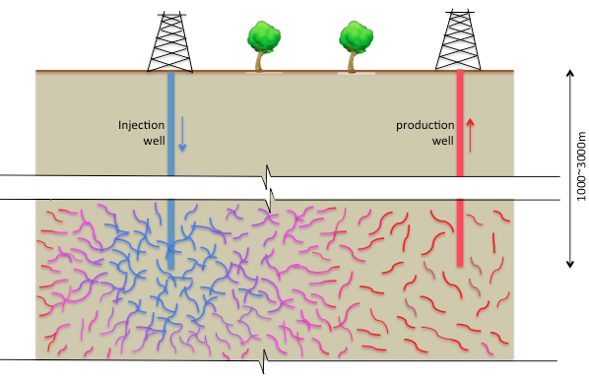
Figure 1. schematic of the stimulation process between a pair of geothermal wells.

References

[1] E. Chabora, et al., Hydraulic stimulation of well 27-15, Desert Peak geothermal field, Nevada, USA, Proceedings of thirty-seventh workshop on geothermal reservoir engineering, Stanford University, Stanford. 30, (2012).
[2] M. Hu, and T. Hueckel, Environmentally enhanced crack propagation in a chemically degrading isotropic shale, Géotechnique 63 (4), 313-321 (2013).
[3] M. O. Ciantia, and T. Hueckel, Weathering of submerged stressed calcarenites: chemo-mechanical coupling mechanisms, Géotechnique 63 (9), 768-785 (2013).
[4] E. Veveakis, T. Poulet, S. Alevizos, Thermo-poro-mechanics of chemically active creeping faults: 2.transient considerations. J. Geophys. Res. Solis Earth 119, 4583-4605 (2014).

